Name: Michael Sullivan | Contact Info: msullivan@vikingmail.org | Date: October 2017

Lesson Title : Access to Energy (Big Idea) | Unit #:  1 | Lesson #:  1 | Activity #:  1
Activity Title: Defining a Challenge to Address Access to Energy

Estimated Lesson Duration: | 1 week
Estimated Activity Duration: | 1 day

Setting: | STEM workshop & computer lab (Grade 11 STEM class)

Activity Objectives:
Students will brainstorm list of essential questions related to human access to energy (specifically, electricity)

Activity Guiding Questions:
- What might prevent a person from having access to electricity?
- What are the consequences of not having access to electricity?
- How do people gain access to electricity?
- When did electricity replace candles and lamps for everyday lighting?
- What kinds of things do people do to improve their access to electricity?

Next Generation Science Standards (NGSS)
Science and Engineering Practices (Check all that apply) | Crosscutting Concepts (Check all that apply)
☒ Asking questions (for science) and defining problems (for engineering) | ☒ Patterns
☐ Developing and using models | ☒ Cause and effect
☐ Planning and carrying out investigations | ☐ Scale, proportion, and quantity
☐ Analyzing and interpreting data | ☒ Systems and system models
☐ Using mathematics and computational thinking | ☒ Energy and matter: Flows, cycles, and conservation
☐ Constructing explanations (for science) and designing solutions (for engineering) | ☐ Structure and function.
☐ Engaging in argument from evidence | ☐ Stability and change.
☒ Obtaining, evaluating, and communicating information

Ohio’s Learning Standards for Science (OLS)
Expectations for Learning - Cognitive Demands (Check all that apply)
☐ Designing Technological/Engineering Solutions Using Science concepts (T)
☒ Demonstrating Science Knowledge (D)
☒ Interpreting and Communicating Science Concepts (C)
☐ Recalling Accurate Science (R)

Ohio’s Learning Standards for Math (OLS) and/or
Common Core State Standards -- Mathematics (CCSS)
Standards for Mathematical Practice (Check all that apply)
☒ Make sense of problems and persevere in solving them | ☐ Use appropriate tools strategically
☐ Reason abstractly and quantitatively | ☐ Attend to precision
☒ Construct viable arguments and critique the reasoning of others | ☐ Look for and make use of structure
☐ Model with mathematics | ☐ Look for and express regularity in repeated reasoning

Unit Academic Standards (NGSS, OLS and/or CCSS):
HS-ETS1-2 (Design a solution to a complex real-world problem by breaking it down into smaller, more manageable problems that can be solved through engineering.)

Materials:

- Quarter-size dry erase boards (8 ea.)
- Dry erase markers (8+ ea.)
- Paper towels or schmattas for wiping the boards (8 ea.)

Teacher Advance Preparation:
No advance preparation is necessary, assuming the dry erase boards are clean.

Activity Procedures:
- Warm up: in Google Classroom, have students answer a posted question: How often do you charge your phone:
  - Never – I do not waste time on such things!
  - Less than once per 24 hours (a couple times each week)
  - Once per 24 hours, on average
  - Twice per 24 hours, on average
  - More than twice per 24 hours – every chance I get!
- Display the aggregated bar graph of the student responses for all to see and comment on any pattern shown.
- Show a brief video of Cincinnati fire chief commenting on effect of brownouts, or the opening 60 seconds of this National Geographic video on blackouts; alternately, select a current event, like the long-term power outages suffered by Puerto Rico residents after Hurricane Maria in September 2017.
- Have the entire class stand up. Turn off the lights and inform them that we are simulating a city-wide, sustained blackout. Conduct a quick survey:
  - Sit down if your phone lasts three or more days without being recharged
  - Sit down if your phone lasts two or more days without being recharged
  - Sit down if your phone lasts 1 or more days without being recharged
  - Sit down if your phone lasts 12 or more hours without being recharged
  - Sit down if your phone lasts 6 or more hours without being recharged
  - Sit down if your phone lasts fewer than 6 hours without being recharged
- Show students this image from the International Energy Agency: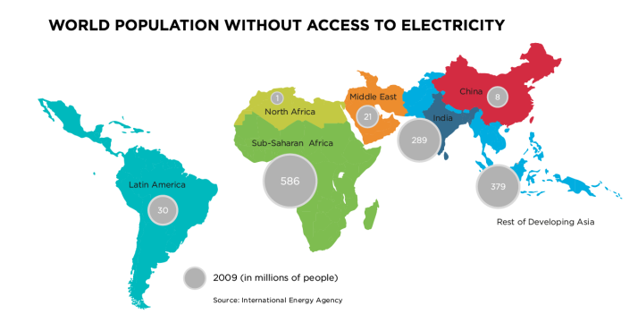
- Have a volunteer approach the display and explain the numbers on the map.
- Remind the students of yesterday’s work on Essential Questions and Guiding Questions, and get student participation to develop a meaningful Essential Question for the class to solve through a challenge. Write that Essential Question up on the board so all can see it and have them record it in the Requirements section of their draft EDP report.
- Distribute white boards, dry erase markers, and schmattas (paper towels or rags). Instruct each student team to use the boards to record possible challenges that would address the Essential Question. After 2 minutes, swap boards between groups. After 2 more minutes, swap boards again. Instruct the students to get back on Google Classroom and to open the posted Google Assignment, which requires students to list the best three challenges they’ve seen and to rank them. Remind the students that the purpose of this assignment is to give the students some control over the next STEM project.

Formative Assessments:

Student submissions of their challenges will be formatively assessed to determine:
- Did they write relevant challenges that can be reasonably attempted within one to two dozen hours of work?
- Did their ranking of the challenges demonstrate understanding of the big idea and the essential question?

Summative Assessments:

Differentiation:

No summative assessment is associated with this activity.

This activity opens with an opportunity for students to talk briefly about their phones and the frustrations they experience topping off battery charge during the school day. Then it has a short, passive introduction (video) that provides a richly contextualized visual and auditory expression of the Big Idea for students to digest. The blackout simulation exercise is nominally kinesthetic and encourages them to imagine a state of deprivation reflecting the Big Idea. The small group brainstorming session provides students with a structured social modality for engaging the Big Idea, and the Google Assignment prompts students to write out their thoughts and to assign ranking (analytic reasoning) on Essential Questions and challenges that effectively address them.

Reflection: After the activity is taught, reflect upon the successes of teaching this Activity in 5 or more sentences. Include a description of what Differentiation strategies worked and what should be changed – justify by presenting evidence and results.

The rotating white boards turned out to be the most useful activity in terms of differentiation and student engagement. Students were simultaneously frustrated and energized by the time constraints as I called out for the boards to rotate. This method also allowed for each student to write or draw on the board or to talk out their thoughts, depending on their most comfortable mode of engaging the assignment. Also of note here is that students were able to crowdsource their preference for challenges. Most of the challenge ideas submitted were realistic and in line with classroom constraints such as tools and materials, and the single most popular idea was the design of a portable electricity-generator, which mirrored the direction in which the lesson was planned and allowed the students to honestly control the direction of the challenge.

I was disappointed by the tepid engagement with regard to the ongoing situation in Puerto Rico. Apparently, Puerto Rico was too remote and the students simply did not identify with the problems being faced on the island. In the future, it would be better to find a hook that is more immediately familiar to the students.

